NAME: Sakshi Aru

Sagar Jadhav

SUBJECT: ADBMS

TOPIC: Public Cyber Incident Reporting Portal

CLASS: MCA (CSDF)

Public Cyber Incident Reporting Portal — ADBMS Project

Part A — Cassandra (CQL) Design and Queries
Overview:
Apache Cassandra is an open-source, distributed NoSQL database designed to handle massive amounts of data across many commodity servers, providing high availability and linear scalability without sacrificing performance.
Key Characteristics:
- NoSQL and Wide-Column Store: Cassandra is a NoSQL database, meaning it doesn't use the traditional relational model. Instead, it employs a wide-column store model, offering flexibility in schema design and efficient storage of sparse data.
- Distributed Architecture: Data is distributed across multiple nodes in a peer-to-peer cluster, with no single point of failure. This design ensures high availability and fault tolerance.
- Tunable Consistency: While Cassandra defaults to an AP (Availability and Partition Tolerance) system under the CAP theorem, prioritizing availability, it offers tunable consistency levels. This allows users to adjust the consistency guarantees for both read and write operations based on application requirements.
- High Availability and Scalability: Its distributed nature and replication strategies provide continuous service even during node failures or planned downtime. Cassandra scales linearly, meaning performance increases with the addition of new nodes.
- Data Model: Cassandra's data model is driven by application needs and requires careful consideration of query patterns during schema design. It utilizes keyspaces (containers for replication) and tables, which are accessed using the Cassandra Query Language (CQL).
- Compaction Strategies: Cassandra employs various compaction strategies (e.g., Size-tiered, Leveled, TimeWindow) to optimize data storage and retrieval, especially for read-heavy or time-series workloads.
- Use Cases: Cassandra is widely used in applications requiring high write throughput, massive data storage, and continuous availability, such as social media platforms, IoT data management, and real-time analytics.

STEP 1 — Install Java (required for Cassandra)
#sudo apt update
#sudo apt install openjdk-11-jdk -y
Verify installation:
#java -version
STEP 2 — Add Apache Cassandra Repository
#echo "deb https://debian.cassandra.apache.org 41x main" | sudo tee /etc/apt/sources.list.d/cassandra.sources.list
Add GPG key
#curl https://downloads.apache.org/cassandra/KEYS | sudo apt-key add -
Update packages
#sudo apt update
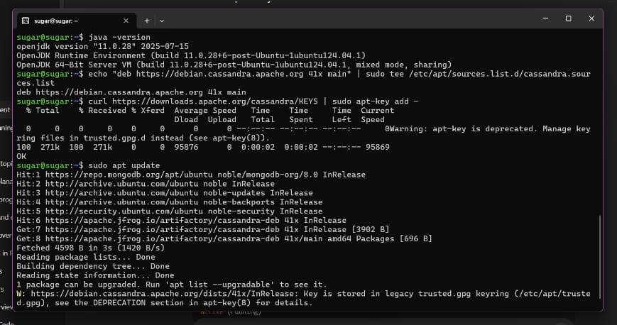
STEP 3 — Start Cassandra service
#sudo systemctl enable cassandra
#sudo systemctl start cassandra
#sudo systemctl status cassandra
STEP 5 — Open CQL shell
#cqlsh
if it works, you will see:
cqlsh>
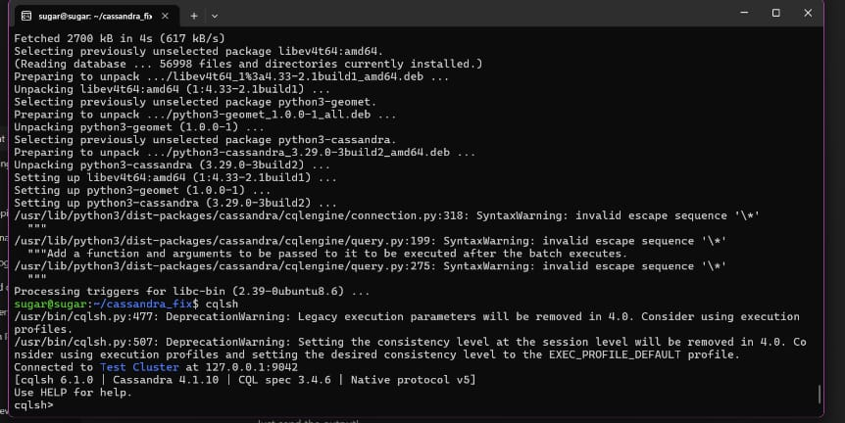

Then its working..
Now we start with Part A- (Database Implementation in Cassandra) for our topic:

Public Cyber Incident Reporting Portal
We will do this step–by–step, and you will run each command inside cqlsh.

STEP 1: Create Keyspace
Go to your terminal (inside cqlsh> prompt) and run:
# CREATE KEYSPACE cyber_portal WITH replication = {
'class': 'SimpleStrategy',
'replication_factor': 1
};
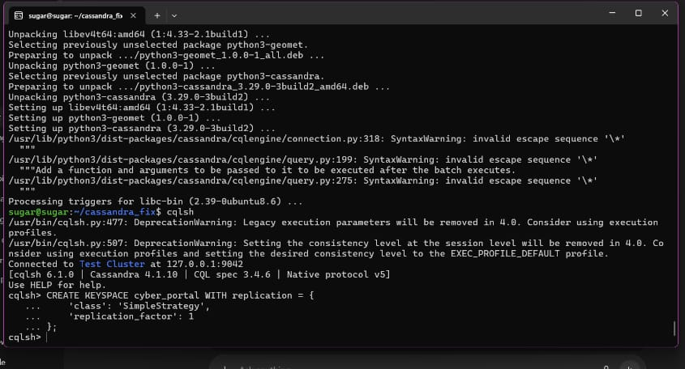
Then switch to it:
# USE cyber_portal;

STEP 2: Create Tables
A cyber incident reporting portal needs these main tables:
- Users Table
# CREATE TABLE users (
user_id UUID PRIMARY KEY,
name text,
email text,
phone text,
address text,
created_at timestamp
);
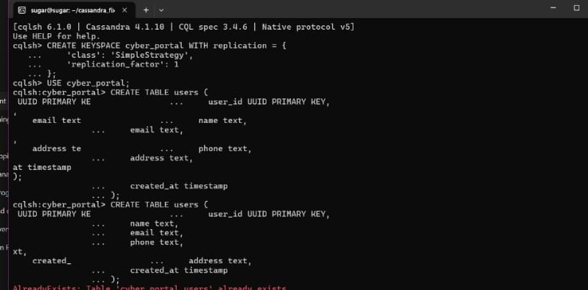

Cyber Incidents Table
Stores general incident information.
#CREATE TABLE cyber_incidents (
incident_id UUID PRIMARY KEY,
reported_by UUID,
category text,
severity text,
description text,
reported_at timestamp
);
- Incident Reports Table
Stores detailed reports attached to an incident
(uses incident_id as partition key and report_id as clustering key).
# CREATE TABLE incident_reports (
incident_id UUID,
report_id UUID,
report_details text,
attached_evidence text,
created_at timestamp,
PRIMARY KEY (incident_id, report_id)
);
- Response Teams Table
# CREATE TABLE response_teams (
team_id UUID PRIMARY KEY,
team_name text,
contact_number text,
region text
);
Image for 2,3 and 4 TABLES
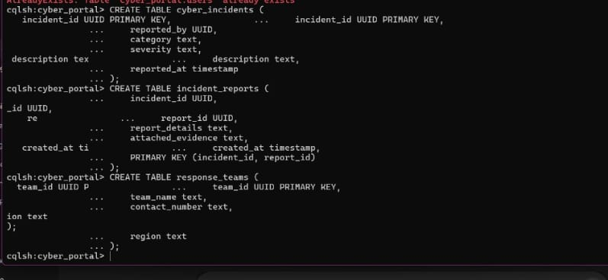

Incident Status Log Table
Tracks the status changes of each incident.
# CREATE TABLE incident_status_log (
incident_id UUID,
status_time timestamp,
status text,
updated_by UUID,
remarks text,
PRIMARY KEY (incident_id, status_time)
);

STEP 3: Insert Sample Data

Insert Users
#INSERT INTO users (user_id, name, email, phone, address, created_at)
VALUES (uuid(), 'Rohan Sharma', 'rohan@gmail.com', '9876543210', 'Delhi, India', toTimestamp(now()));

INSERT INTO users (user_id, name, email, phone, address, created_at)
VALUES (uuid(), 'Priya Verma', 'priya@gmail.com', '9812345670', 'Mumbai, India', toTimestamp(now()));
IMAGE FOR Table 5 and Insert Users
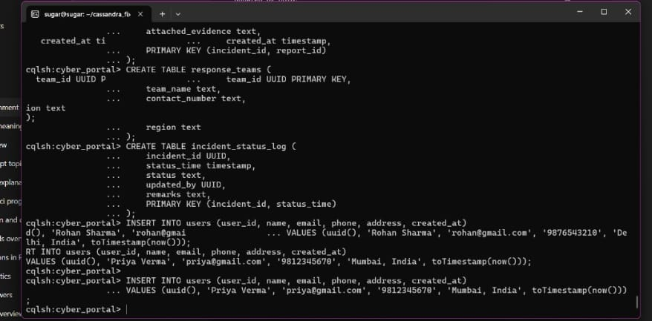

Insert Cyber Incidents
# INSERT INTO cyber_incidents (incident_id, reported_by, category, severity, description, reported_at)
VALUES (uuid(), uuid(), 'Phishing', 'High', 'Fake bank email asking for OTP', toTimestamp(now()));

INSERT INTO cyber_incidents (incident_id, reported_by, category, severity, description, reported_at)
VALUES (uuid(), uuid(), 'Malware Attack', 'Critical', 'Ransomware attack on system files', toTimestamp(now()));
3.Insert Incident Reports
# INSERT INTO incident_reports (incident_id, report_id, report_details, attached_evidence, created_at)
VALUES (uuid(), uuid(), 'User submitted screenshots of suspicious email', 'email_screenshot.jpg', toTimestamp(now()));
IMAGE OF 2 AND 3.
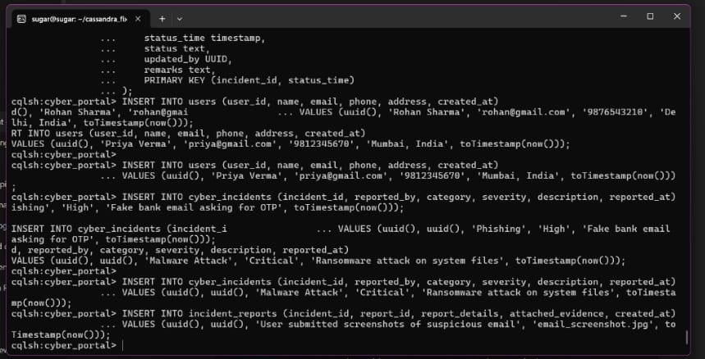

4. Insert Response Teams
INSERT INTO response_teams (team_id, team_name, contact_number, region)VALUES (uuid(), 'CERT-Delhi', '1800-111-234', 'North Region');
INSERT INTO response_teams (team_id, team_name, contact_number, region)VALUES (uuid(), 'CERT-Mumbai', '1800-222-345', 'West Region');

5. Insert Status Log
INSERT INTO incident_status_log (incident_id, status_time, status, updated_by, remarks)VALUES (uuid(), toTimestamp(now()), 'Investigating', uuid(), 'Team assigned and analysis started');
Image for 4 and 5.
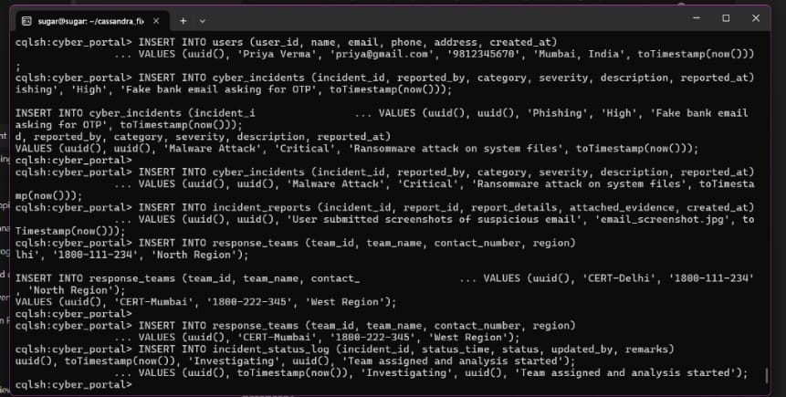

Here part A is completed some queries are there which we cannot run on cassandra so we use sql or nosql for that.

Part B - Execution of Queries on SQL.

Exit from cqlsh
In your terminal (where you see cqlsh:cyber_portal>), type:
exit;
or press:
Ctrl + D
This will return you to:
sugar@sugar:~$

Step 1: Check if SQLite is already installed

Run this in your Ubuntu terminal:
# sqlite3 --version
Then install SQLite with:
# sudo apt install sqlite3 -y
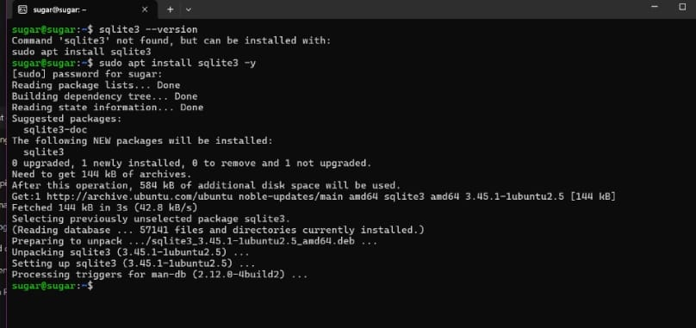

After installation finishes, confirm by running:
sqlite3 --version
You should see something like:
3.40.1

Step 2: Create SQLite Database File
Run this in terminal (NOT inside cqlsh):
sqlite3 partA_cyberportal.db
Your prompt will change to:
sqlite>
This means SQLite is open.
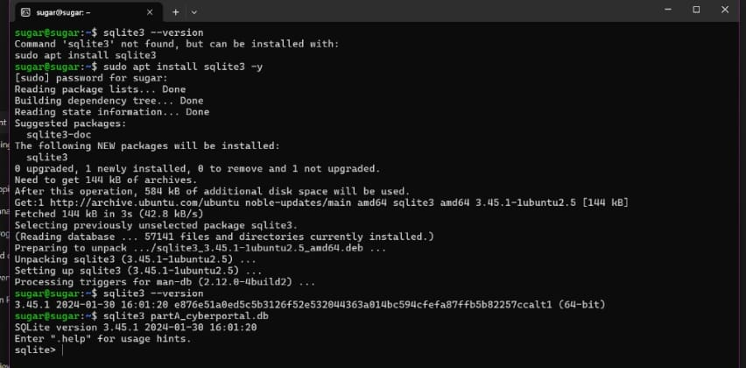

STEP 3 — Create Tables (PART B SQL)
Write each block inside sqlite>

Users Table
CREATE TABLE users (
user_id TEXT PRIMARY KEY,
name TEXT,
email TEXT,
phone TEXT,
address TEXT,
created_at TEXT
);

2. Cyber Incidents Table
CREATE TABLE cyber_incidents (
incident_id TEXT PRIMARY KEY,
reported_by TEXT,
category TEXT,
severity TEXT,
description TEXT,
reported_at TEXT
);

3. Incident Reports Table

CREATE TABLE incident_reports (
report_id TEXT PRIMARY KEY,
incident_id TEXT,
report_details TEXT,
evidence TEXT,
created_at TEXT
);

4. Response Teams Table
CREATE TABLE response_teams (
team_id TEXT PRIMARY KEY,
team_name TEXT,
contact_number TEXT,
region TEXT
);
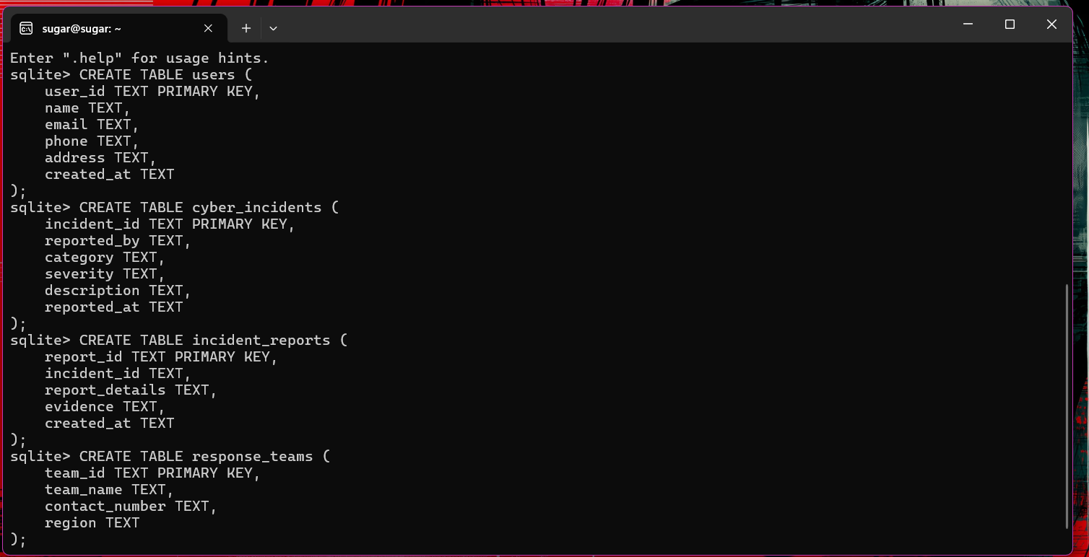

5. Incident Status Log Table
CREATE TABLE incident_status_log (
log_id TEXT PRIMARY KEY,
incident_id TEXT,
status TEXT,
status_time TEXT,
remarks TEXT
);
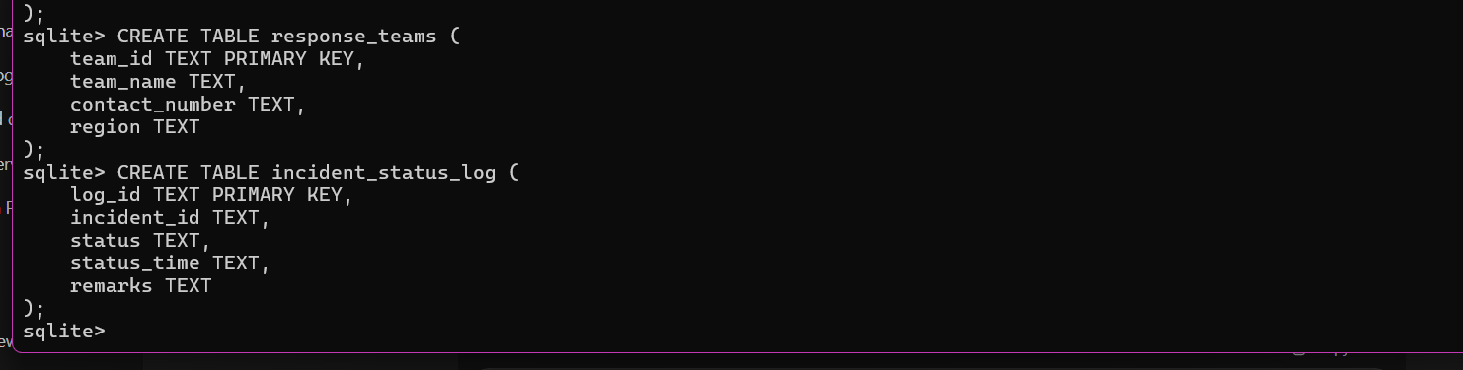

Type this to see all tables:
.tables
STEP 4 — Insert Sample Data

STEP 4 : Insert Sample Data into All Tables
Write each block inside sqlite>

✅ Insert into users
INSERT INTO users VALUES
('U001', 'Rohan Sharma', 'rohan@gmail.com', '9876543210', 'Delhi', datetime('now')),
('U002', 'Priya Verma', 'priya@gmail.com', '9812345670', 'Mumbai', datetime('now'));

✅ Insert into cyber_incidents
INSERT INTO cyber_incidents VALUES
('I001', 'U001', 'Phishing', 'High', 'Fake bank OTP request email', datetime('now')),
('I002', 'U002', 'Malware Attack', 'Critical', 'Ransomware attack on Windows system', datetime('now'));

✅ Insert into incident_reports

INSERT INTO incident_reports VALUES
('R001', 'I001', 'User provided fake email screenshot', 'screenshot1.jpg', datetime('now')),
('R002', 'I002', 'User uploaded ransomware message image', 'ransom_note.jpg', datetime('now'));
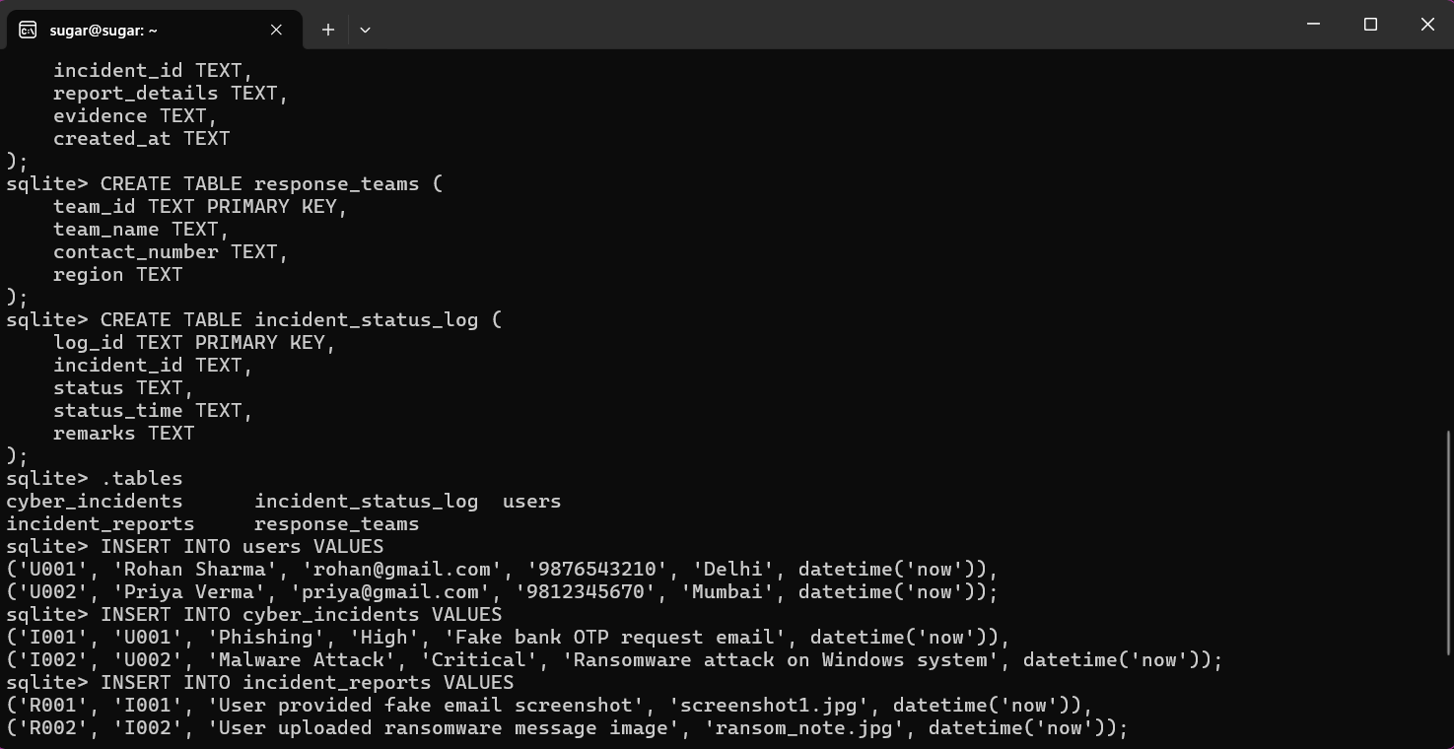

Insert into response_teams
INSERT INTO response_teams VALUES
('T001', 'CERT-Delhi', '1800-111-234', 'North'),
('T002', 'CERT-Mumbai', '1800-222-345', 'West');

✅ Insert into incident_status_log
INSERT INTO incident_status_log VALUES
('L001', 'I001', 'Investigating', datetime('now'), 'Team assigned and analysis started'),
('L002', 'I002', 'Under Review', datetime('now'), 'Waiting for full scan report');

STEP 5 : Verify Data
Run: SELECT * FROM users;
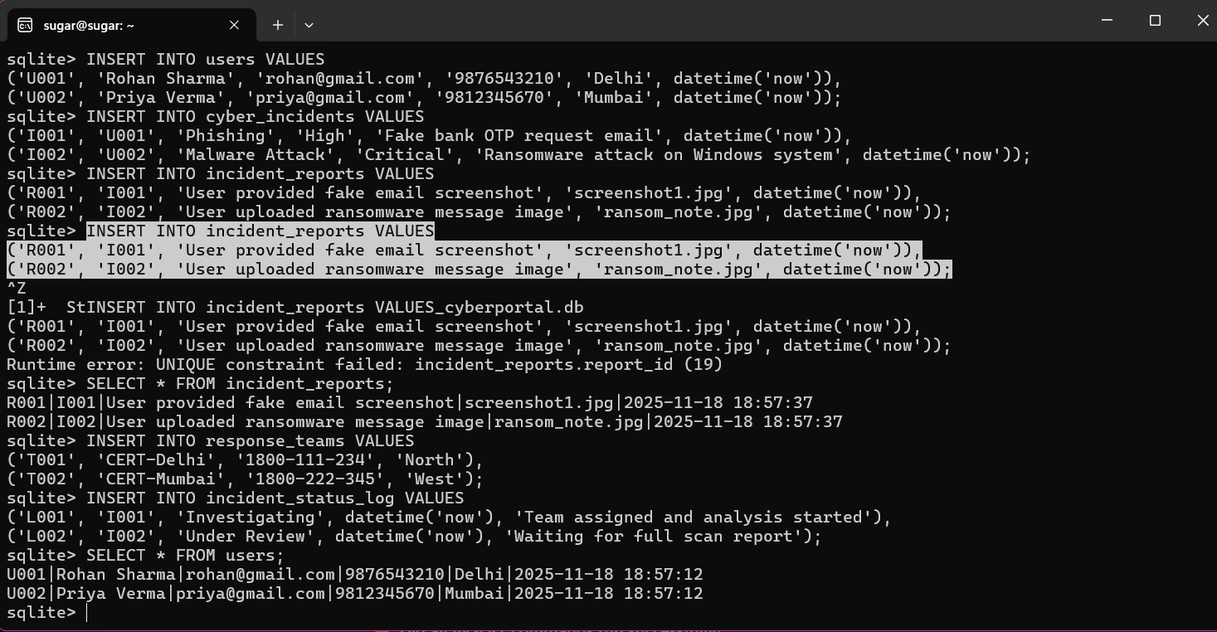

Once its done, we will start Relational Algebra Queries for Part B :

✔ Selection (σ)

✔ Projection (π)

✔ Join (⨝)

✔ Union (∪)

✔ Intersection (∩)

✔ Difference (−)

✔ Aggregation (COUNT, MAX, MIN)

✔ Group B

✔ Nested queries

PART B SQL QUERIES (EXECUTION)

1. SELECTION (σ)
Get all high severity incidents:
SELECT * FROM cyber_incidentsWHERE severity = 'High';

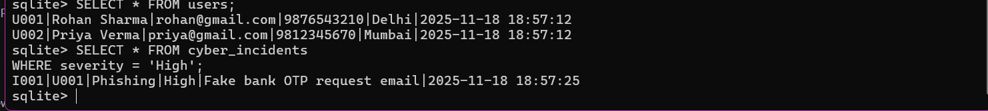

2. PROJECTION (π)
Show only names and emails of users:
SELECT name, email FROM users;

3.SELECTION + PROJECTION COMBINED
SELECT name FROM usersWHERE address = 'Delhi';

4. JOIN (⨝)
Join users with incidents they reported:
SELECT users.name, cyber_incidents.category, cyber_incidents.severityFROM usersJOIN cyber_incidentsON users.user_id = cyber_incidents.reported_by;

5. LEFT JOIN
Show all incidents with their reports:
SELECT ci.incident_id, ci.category, ir.report_detailsFROM cyber_incidents ciLEFT JOIN incident_reports irON ci.incident_id = ir.incident_id;
Image for 2,3,4 AND 5.

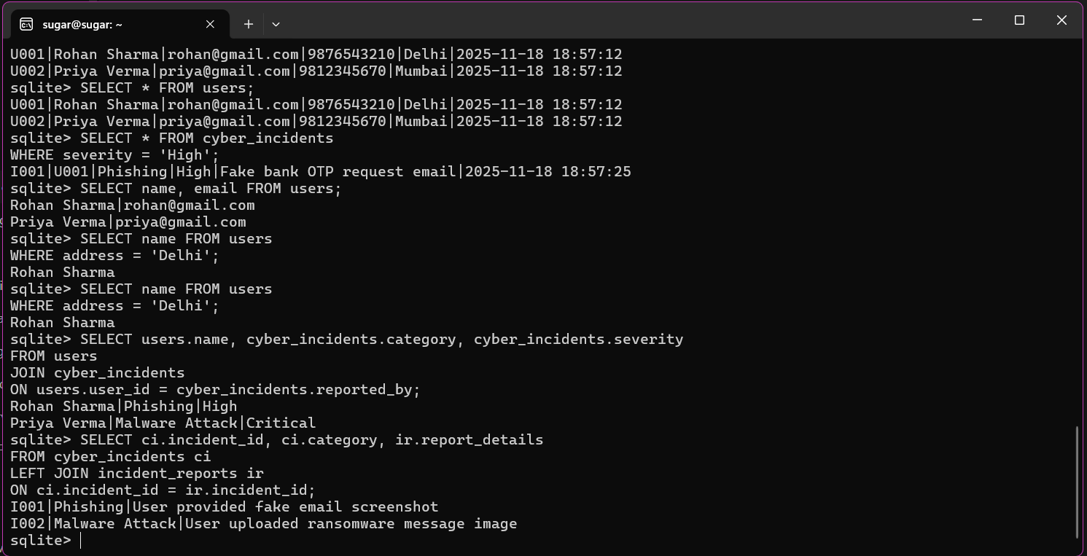

6. UNION (∪)
(Not meaningful with your data but required for assignment)
Get all team regions or user cities:
SELECT region FROM response_teamsUNIONSELECT address FROM users;

7. INTERSECTION (∩)
SQLite doesn't have direct INTERSECT, but supports:
SELECT address FROM usersINTERSECTSELECT region FROM response_teams;

8. DIFFERENCE (−)
SELECT address FROM usersEXCEPTSELECT region FROM response_teams;

IMAGE OF 6,7 AND 8.

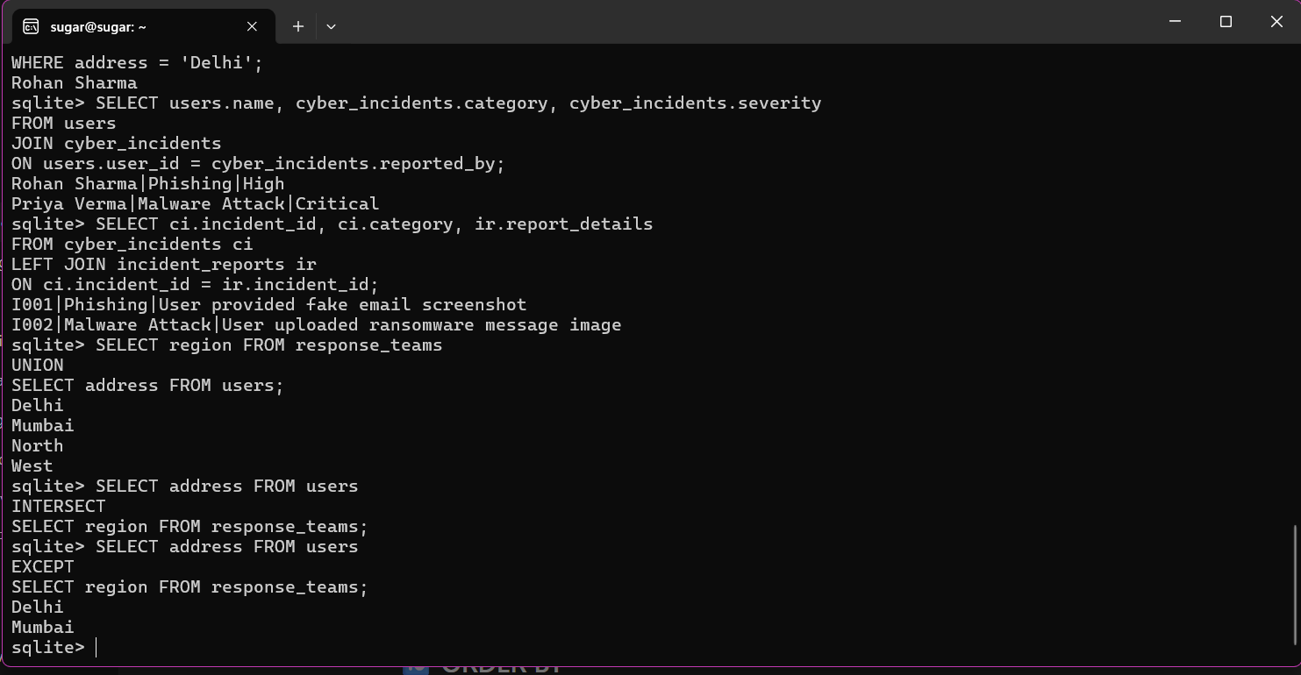

9. AGGREGATION (COUNT)
How many incidents per severity:
SELECT severity, COUNT(*) FROM cyber_incidentsGROUP BY severity;

10. ORDER BY
SELECT * FROM usersORDER BY name ASC;

11.Nested Query
Find all users who reported an incident:
SELECT * FROM usersWHERE user_id IN (
SELECT reported_by FROM cyber_incidents
);

IMAGE FOR 9,10 AND 11.
